Apply non-linear filters (median or other rank filters) to remove noise from data/images provided in OPE7 and perform comprehensive analysis. (CO3, CO4)
Identify noise types present in the dataset (salt-and-pepper, impulse, speckle, etc.).
Implement median filtering with varying window sizes and, optionally, other non-linear filters (alpha-trimmed mean, morphological filters).
Analyze how filter size and type affect detail preservation vs. noise removal.
Observations: optimum filter sizes per noise type, edge preservation analysis, and failure cases.
Summarize best-performing methods for each noise type and practical recommendations.

Setup:
Code:-
import cv2
import numpy as np
import matplotlib.pyplot as plt
from numpy.lib.stride_tricks import sliding_window_view

# Images provided in OPE7 (loaded as grayscale)
man = cv2.imread('man.png', 0)
knee = cv2.imread('knee.png', 0)
city = cv2.imread('city.png', 0)
building = cv2.imread('building.png', 0)

# Alpha trimmed mean filter : sort the window, remove d/2 smallest and d/2 largest values, average the rest
def alpha_trimmed_mean(img, size=5, d=8):
pad = size // 2
padded = np.pad(img, pad, mode='reflect')
windows = sliding_window_view(padded, (size, size)).reshape(img.shape[0], img.shape[1], -1)
windows = np.sort(windows, axis=2)
trimmed = windows[:, :, d // 2: size * size - d // 2]
return trimmed.mean(axis=2).astype(np.uint8)

# Morphological filter : opening followed by closing
def open_close(img, size=3):
kernel = np.ones((size, size), np.uint8)
opened = cv2.morphologyEx(img, cv2.MORPH_OPEN, kernel)
return cv2.morphologyEx(opened, cv2.MORPH_CLOSE, kernel)

# Function to show images in a row
def show(images, titles, size=(14, 4), cmap='gray'):
plt.figure(figsize=size)
for i in range(len(images)):
plt.subplot(1, len(images), i + 1)
plt.imshow(images[i], cmap=cmap, vmin=0, vmax=255)
plt.title(titles[i])
plt.axis('off')
plt.tight_layout()
plt.show()

1. Identify the noise type
Code:-
# Impulse (salt and pepper) noise : pixels which differ a lot from the median of their neighbourhood
for name, img in [('man', man), ('knee', knee), ('city', city), ('building', building)]:
diff = np.abs(img.astype(int) - cv2.medianBlur(img, 5))
print(f"{name:9s} pixels differing from 5x5 median by more than 80 levels : {100 * np.mean(diff > 80):.1f} %")

# Periodic noise : strong isolated peaks in the Fourier spectrum
def spectrum(img):
return np.abs(np.fft.fftshift(np.fft.fft2(img - img.mean())))

def peak_ratio(img):
F = spectrum(img)
c0, c1 = F.shape[0] // 2, F.shape[1] // 2
G = F.copy()
G[c0 - 3:c0 + 4, c1 - 3:c1 + 4] = 0 # ignore the centre (DC) region
return G.max() / np.median(F)

for name, img in [('man', man), ('knee', knee), ('city', city), ('building', building)]:
print(f"{name:9s} strongest Fourier peak / median of spectrum : {peak_ratio(img):.1f}")

show([np.log1p(spectrum(city)), np.log1p(spectrum(building))],
['Spectrum of city image', 'Spectrum of building image'], size=(12, 4))

Output:-
man pixels differing from 5x5 median by more than 80 levels : 1.9 %
knee pixels differing from 5x5 median by more than 80 levels : 14.8 %
city pixels differing from 5x5 median by more than 80 levels : 2.2 %
building pixels differing from 5x5 median by more than 80 levels : 0.0 %
man strongest Fourier peak / median of spectrum : 94.4
knee strongest Fourier peak / median of spectrum : 29.2
city strongest Fourier peak / median of spectrum : 117.8
building strongest Fourier peak / median of spectrum : 935.1
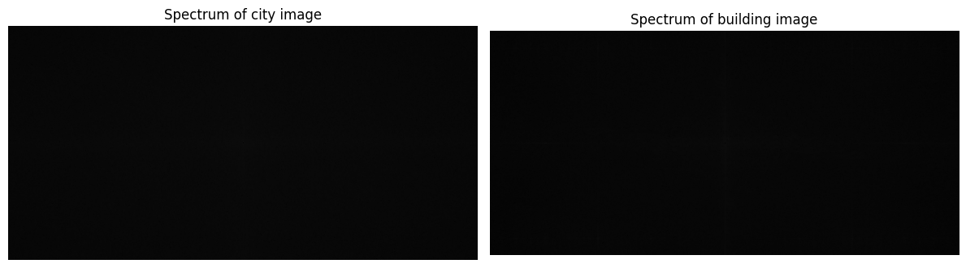

2. Median filter with different window sizes (salt and pepper noise)
Code:-
for name, img in [('Man', man), ('Knee', knee)]:
results = [cv2.medianBlur(img, k) for k in (3, 5, 7)]
show([img] + results, [name + ' (noisy)', 'Median 3x3', 'Median 5x5', 'Median 7x7'])

Output:-
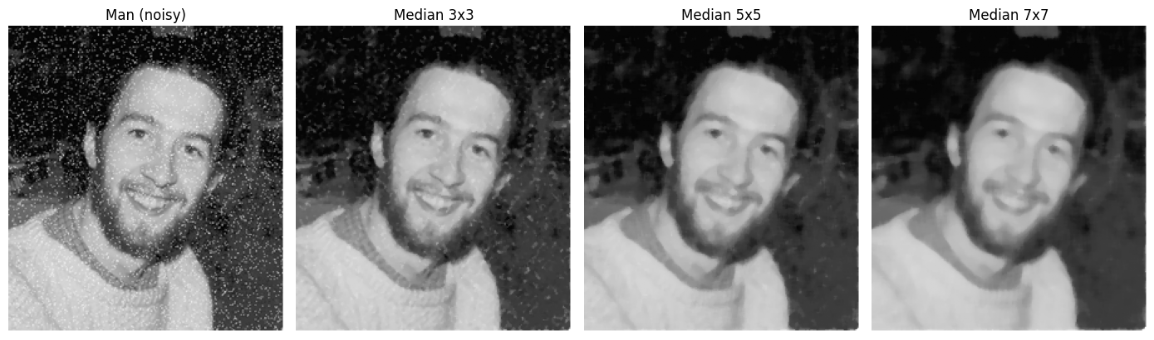
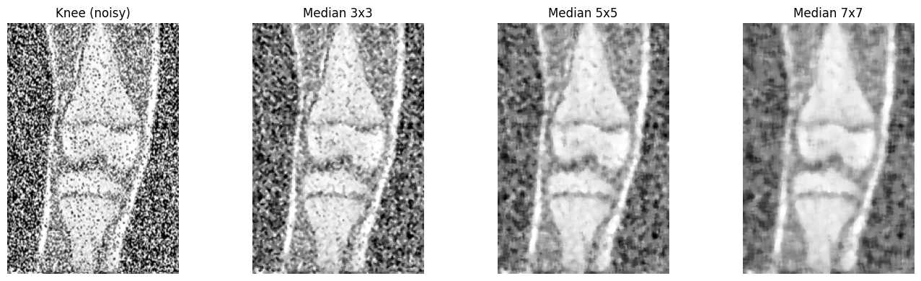

3. Other non-linear filters (alpha trimmed mean and morphological filter)
Alpha trimmed mean: the window values are sorted, d/2 smallest and d/2 largest values are removed and the remaining values are averaged. Morphological filter: opening followed by closing.
Code:-
for name, img in [('Man', man), ('Knee', knee)]:
show([img, cv2.medianBlur(img, 5), alpha_trimmed_mean(img, 5, 8), alpha_trimmed_mean(img, 5, 16), open_close(img, 3)],
[name + ' (noisy)', 'Median 5x5', 'Alpha trimmed 5x5 (d=8)', 'Alpha trimmed 5x5 (d=16)', 'Open-Close 3x3'], size=(18, 4))

Output:-
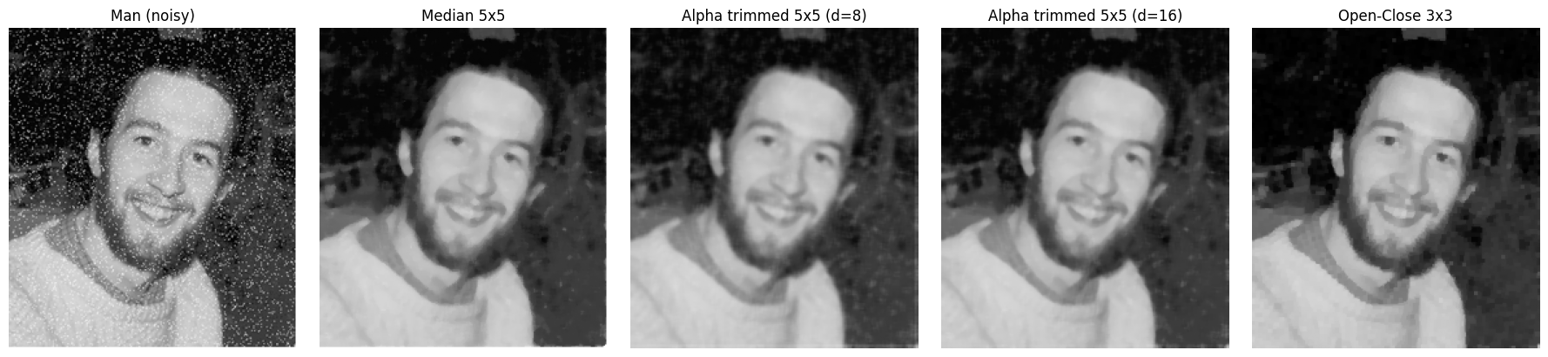
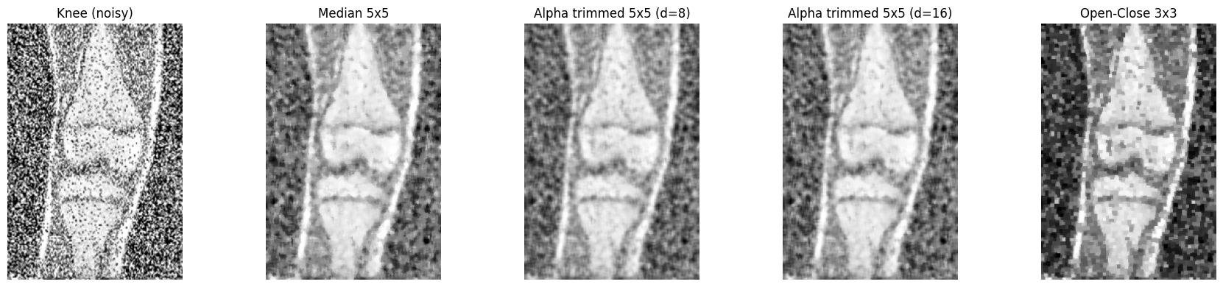

4. Median filter on the images with periodic stripe noise
Code:-
for name, img in [('City', city), ('Building', building)]:
results = [cv2.medianBlur(img, k) for k in (3, 5, 9)]
show([img] + results, [name + ' (noisy)', 'Median 3x3', 'Median 5x5', 'Median 9x9'])
print(name, "strongest Fourier peak / median : original =", round(peak_ratio(img), 1),
", 3x3 =", round(peak_ratio(results[0]), 1), ", 5x5 =", round(peak_ratio(results[1]), 1),
", 9x9 =", round(peak_ratio(results[2]), 1))

Output:-
City strongest Fourier peak / median : original = 117.8 , 3x3 = 275.0 , 5x5 = 451.2 , 9x9 = 909.9
Building strongest Fourier peak / median : original = 935.1 , 3x3 = 1750.1 , 5x5 = 3175.2 , 9x9 = 5326.3
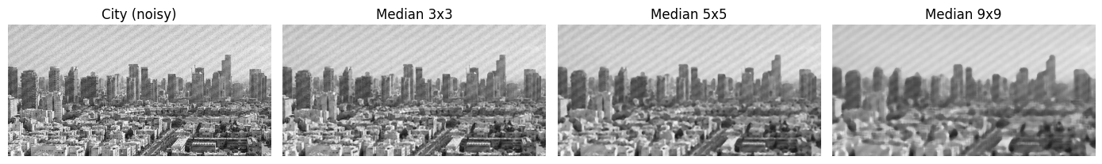
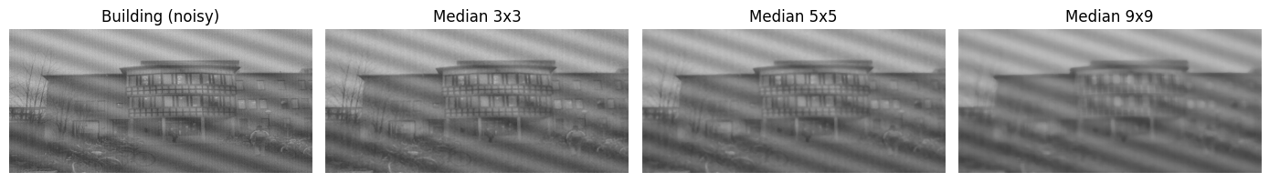

5. Controlled experiment on a clean reference image
The provided images do not have a noise free original, so salt and pepper noise (5 %, 20 %, 40 %) and speckle noise were added to a clean image (clean_reference.png, the standard "cameraman" test image) and the filters were compared using PSNR and edge PSNR (PSNR calculated only on the edge pixels).
Code:-
clean = cv2.imread('clean_reference.png', 0)
rng = np.random.default_rng(1)

# Add noise of different types
def salt_pepper(img, p):
out = img.copy()
r = rng.random(img.shape)
out[r < p / 2] = 0
out[r > 1 - p / 2] = 255
return out

def speckle(img, var):
n = rng.normal(0, np.sqrt(var), img.shape)
return np.clip(img + img * n, 0, 255).astype(np.uint8)

noisy_images = {
'Salt & pepper 5%': salt_pepper(clean, 0.05),
'Salt & pepper 20%': salt_pepper(clean, 0.20),
'Salt & pepper 40%': salt_pepper(clean, 0.40),
'Speckle (var 0.1)': speckle(clean, 0.1),
}

# PSNR and edge PSNR
def psnr(a, b):
return 10 * np.log10(255 ** 2 / np.mean((a.astype(float) - b.astype(float)) ** 2))

edge_mask = cv2.dilate(cv2.Canny(clean, 100, 200), np.ones((3, 3), np.uint8)) > 0

def edge_psnr(a, b):
return 10 * np.log10(255 ** 2 / np.mean((a[edge_mask].astype(float) - b[edge_mask].astype(float)) ** 2))

filters = {
'Noisy': lambda x: x,
'Median 3x3': lambda x: cv2.medianBlur(x, 3),
'Median 5x5': lambda x: cv2.medianBlur(x, 5),
'Median 7x7': lambda x: cv2.medianBlur(x, 7),
'AlphaTrim 5x5': lambda x: alpha_trimmed_mean(x, 5, 8),
'Open-Close 3x3': lambda x: open_close(x, 3),
}

filtered = {}
print("PSNR (dB)")
print(f"{'':20s}" + "".join(f"{f:>16s}" for f in filters))
for nname, nimg in noisy_images.items():
row = f"{nname:20s}"
for fname, f in filters.items():
filtered[(nname, fname)] = f(nimg)
row += f"{psnr(clean, filtered[(nname, fname)]):16.2f}"
print(row)

print()
print("Edge PSNR (dB)")
print(f"{'':20s}" + "".join(f"{f:>16s}" for f in filters))
for nname in noisy_images:
row = f"{nname:20s}"
for fname in filters:
row += f"{edge_psnr(clean, filtered[(nname, fname)]):16.2f}"
print(row)

Output:-
PSNR (dB)
Salt & pepper 5% : Noisy 17.81, Median 3x3 30.15, Median 5x5 27.86, Median 7x7 26.27, AlphaTrim 5x5 27.32, Open-Close 3x3 26.00
Salt & pepper 20% : Noisy 11.74, Median 3x3 26.90, Median 5x5 27.20, Median 7x7 25.96, AlphaTrim 5x5 25.52, Open-Close 3x3 16.20
Salt & pepper 40% : Noisy 8.74, Median 3x3 18.14, Median 5x5 25.42, Median 7x7 25.16, AlphaTrim 5x5 19.54, Open-Close 3x3 8.22
Speckle (var 0.1) : Noisy 15.74, Median 3x3 21.88, Median 5x5 23.92, Median 7x7 24.03, AlphaTrim 5x5 24.63, Open-Close 3x3 15.67
Edge PSNR (dB)
Salt & pepper 5% : Noisy 18.49, Median 3x3 24.93, Median 5x5 22.27, Median 7x7 20.62, AlphaTrim 5x5 21.66, Open-Close 3x3 20.72
Salt & pepper 20% : Noisy 12.37, Median 3x3 22.58, Median 5x5 21.54, Median 7x7 20.27, AlphaTrim 5x5 20.69, Open-Close 3x3 14.30
Salt & pepper 40% : Noisy 9.34, Median 3x3 17.19, Median 5x5 20.03, Median 7x7 19.43, AlphaTrim 5x5 17.93, Open-Close 3x3 8.10
Speckle (var 0.1) : Noisy 15.46, Median 3x3 20.35, Median 5x5 20.30, Median 7x7 19.38, AlphaTrim 5x5 20.48, Open-Close 3x3 14.89

# Visual comparison : best and failure cases
show([clean, noisy_images['Salt & pepper 5%'], filtered[('Salt & pepper 5%', 'Median 3x3')], filtered[('Salt & pepper 5%', 'Median 7x7')]],
['Clean image', 'Salt & pepper 5%', 'Median 3x3', 'Median 7x7 (loss of detail)'])

show([clean, noisy_images['Salt & pepper 40%'], filtered[('Salt & pepper 40%', 'Median 3x3')], filtered[('Salt & pepper 40%', 'Median 7x7')]],
['Clean image', 'Salt & pepper 40%', 'Median 3x3 (noise remains)', 'Median 7x7'])

show([clean, noisy_images['Speckle (var 0.1)'], filtered[('Speckle (var 0.1)', 'Median 3x3')], filtered[('Speckle (var 0.1)', 'AlphaTrim 5x5')]],
['Clean image', 'Speckle noise', 'Median 3x3', 'Alpha trimmed 5x5'])

Output:-
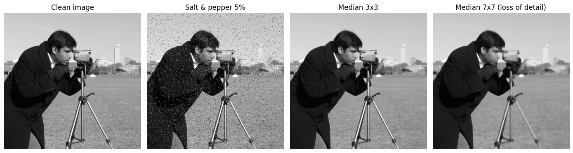
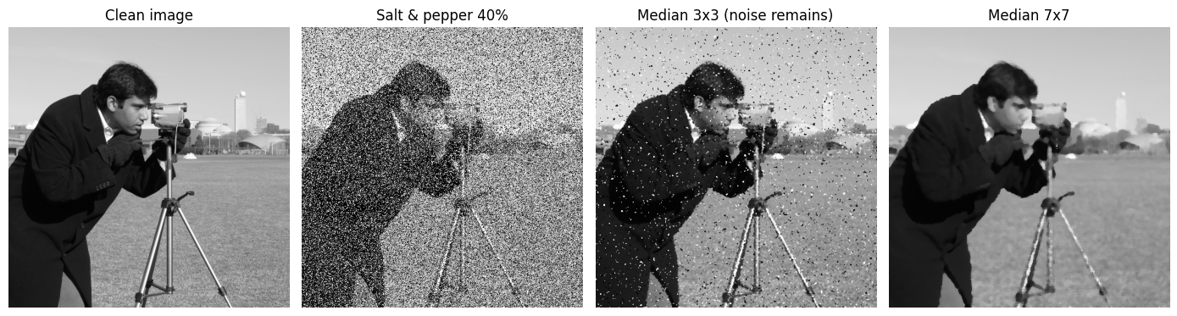
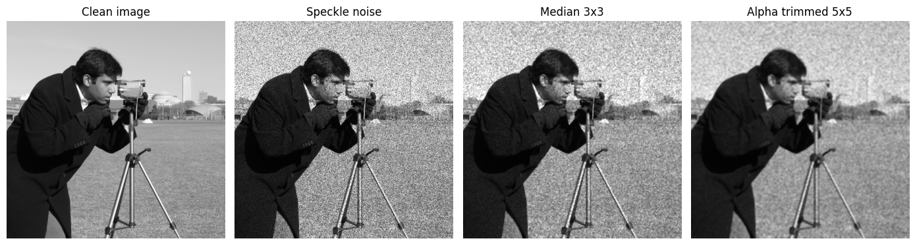

Observations:-
Noise types: The man and knee images have salt and pepper (impulse) noise, which is seen as isolated white and black dots. It is much denser in the knee image (about 14.8 % of the pixels differ by more than 80 levels from the 5 x 5 median, compared with 1.9 % for the man image; the real density is higher because many noisy pixels have a value close to their neighbours). The city and building images have periodic (stripe) noise, because their Fourier spectrum shows isolated strong peaks (the strongest peak is 118 times the median spectrum value for the city image and 935 times for the building image).
Man image: The 3 x 3 median removes most of the dots but some remain in the dark background. The 5 x 5 median removes almost all of them and the face, eyes and beard are still clear. The 7 x 7 median makes the image smooth and the fine details of the beard and the sweater are lost. The best window is 5 x 5.
Knee image: Because the noise is dense, the 3 x 3 median leaves many dots. The 5 x 5 median removes most of the noise and the bone edges are kept, but a mottled texture remains in the background. The 7 x 7 median gives a smoother image but blurs the joint details. The best window is 5 x 5.
Optimum window size per noise type (controlled experiment, PSNR): For 5 % salt and pepper noise the 3 x 3 median is best (30.15 dB, against 27.86 dB for 5 x 5 and 26.27 dB for 7 x 7). For 20 % noise the 5 x 5 median is best (27.20 dB, while 3 x 3 gives 26.90 dB). For 40 % noise the 5 x 5 median is best (25.42 dB) and the 3 x 3 median fails (18.14 dB). So the optimum window grows with the noise density. For speckle noise the larger windows are better (21.88 dB for 3 x 3, 23.92 dB for 5 x 5 and 24.03 dB for 7 x 7) but the improvement is smaller than for impulse noise.
Edge preservation: The edge PSNR is always lower than the full image PSNR (about 5 dB for the best filters), so edges are the hardest part to restore. For 5 % noise the edge PSNR falls from 24.93 dB (3 x 3) to 22.27 dB (5 x 5) and 20.62 dB (7 x 7), so a larger window damages the edges more. In the 7 x 7 result the thin legs of the tripod are broken and small details disappear. Edges are preserved best when the smallest window which removes the impulses is used.
Alpha trimmed mean (5 x 5, d = 8): It gives 27.32 dB for 5 % noise and 25.52 dB for 20 % noise, which is lower than the median for impulse noise, and it fails at 40 % noise (19.54 dB), because the trimmed values (4 on each side, 16 %) are fewer than the noisy values in the window. For speckle noise it is the best filter (24.63 dB PSNR and 20.48 dB edge PSNR).
Morphological filter (opening and closing, 3 x 3): It works for 5 % noise (26.00 dB) but it gives only 16.20 dB for 20 % noise and 8.22 dB for 40 % noise, which is no improvement over the noisy image (8.74 dB), and for speckle noise it gives no improvement (15.67 dB against 15.74 dB). On the knee image it gives a blocky result.
Failure cases: (1) The 3 x 3 median at 40 % salt and pepper noise leaves a lot of noise. (2) Large windows (7 x 7 or 9 x 9) remove thin lines and small details. (3) Alpha trimmed mean with too little trimming and the morphological filter at high noise density. (4) Periodic stripe noise: for the city and building images the stripes remain visible for 3 x 3, 5 x 5 and 9 x 9 median windows, and the ratio of the strongest spectrum peak to the median spectrum value increases (city: 117.8 to 275.0, 451.2 and 909.9; building: 935.1 to 1750.1, 3175.2 and 5326.3), which means that the stripes become stronger compared to the rest of the image while the image details are blurred.

Best performing methods and practical recommendations:-
Salt and pepper noise, low density (about 5 % or less): median 3 x 3 (best PSNR 30.15 dB and best edge PSNR 24.93 dB).
Salt and pepper noise, medium and high density (20 % to 40 %): median 5 x 5 (27.20 dB and 25.42 dB). For the very dense knee image a 5 x 5 median is the best compromise.
Speckle noise: alpha trimmed mean 5 x 5 (24.63 dB), with a median of 5 x 5 or 7 x 7 as the next best; the morphological filter is not suitable.
Periodic stripe noise: median and other non-linear spatial filters are not suitable. A frequency domain notch filter, which removes the peaks seen in the Fourier spectrum, should be used.
Practical recommendations: first identify the noise type and estimate the noise density, then choose the smallest window which removes the noise, because a larger window removes more detail and edges. For alpha trimmed mean, the number of trimmed values on each side must be larger than the number of noisy pixels expected in the window. Do not use the morphological filter for dense noise.

Conclusion
Non-linear rank filters remove impulse noise very well without blurring the edges as much as linear filters, but the window size must match the noise density: a small window for low density and a larger window for high density. For speckle noise the improvement is smaller and the alpha trimmed mean is the best choice, and for periodic noise the non-linear spatial filters fail and a frequency domain filter is required.

